Task No & Title: | BSBCMN211A Participate in workplace safety procedures
Title: | Ergonomics Explained worksheet
Suitable for Classes: | Certificate II Business Cert II in ICT
Area: | Technology & Enterprise
Teacher: | Mr Peter Faulks
Timeline | 1 Lesson
Date Due: | Today

Task Brief:
Files Required | Camera

Items highlighted in yellow are tasks for you to complete
Items in Blue are help tips

ERG101 Ergonomics Equipment Worksheet
1. What issues need to be taken into account when considering the placement of computing or office equipment in a work environment.

At lease four elements MUST be discussed

Using a camera take photographic examples of your answers.

valid points may include:
- sturdy equipment, benches or tables not trollies
- poor quality seating, no computer chairs
- out of direct sunlight, glare onto screen or into eyes
- no window behind operator
- cables and cords out of the way, properly clipped together not trailing across a floor
- height and tilt adjustment on chairs or computers
- printers and phone and other equipment easy to reach
- Multiple devices into one power point

Save the work

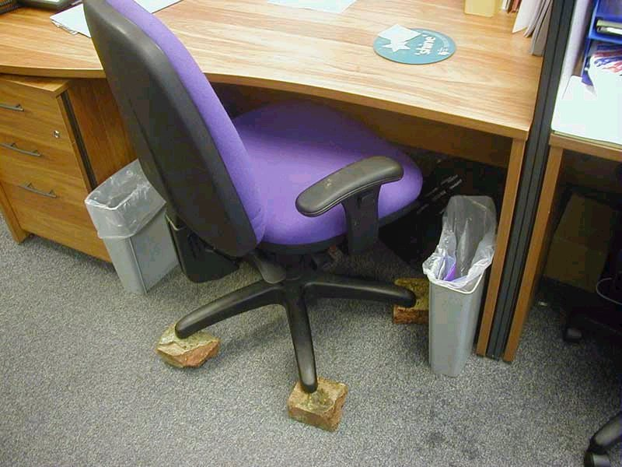
Case Study:
David is sitting at his desk. He adjusts his chair up and down and then backwards and forwards, before adjusting the computer screen and keyboard. He then swaps the mouse over to the right hand side of the keyboard and says "Ah that's much more comfortable" and smiles.
(Telephone is on the very edge of the desk, out of reach of David. He does not adjust this).

- In what order should you adjust your workstation to suit your ergonomic requirements?
Answer adjust the Computer

- Did David adjust his workstation in the correct sequence? Explain.

Answer: No should start with computer then eyes to screen then chair

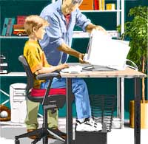

- What item did David neglect to adjust on his desktop?

Answer a communication device like a telephone

- Examine your own work area from an Occupational Health and Safety perspective. Are any improvements necessary? Talk to your supervisor about any areas of concern for your safety and the safety of others.

Answers will vary

Chair:
Your chair height should be set so that your feet are flat on the floor (where a footrest has not been provided) and your thighs are horizontal. The backrest should provide firm lower back support so you may need to adjust up or down, backwards or forwards until you feel comfortable. Armrests should not interfere with your performance of general tasks.

Desk:
Raise the height of your desk or chair to adjust the surface of the desk to the height of your elbow (when sitting). Ask for assistance to adjust the height of your desk if it is not height adjustable. Allow plenty of room for your legs below the desk surface and arrange your personal and stationery items for easy access, to minimise twisting and bending.

Computer:
Your PC should be positioned after you have adjusted your desk and chair. It is recommended that the top of the screen be level with your eyes and be positioned about 50cm away from your body when seated. Place the keyboard as close to you on the desk as possible and allow room for it to be moved away when not in use. The angle of the keyboard can be adjusted by altering the supports underneath. The mouse should be positioned next to the keyboard on your preferred side. Your wrist should be straight whilst using the mouse with the desk supporting your wrist and not your arm.

Telephone:
The telephone should be easily accessible, yet not in the way of your work area. You should be able to talk on the phone without standing or having to stretch to reach it. A headset is a convenient alternative for constant phone users.

Document holder:
The document holder should be placed close to your screen to minimise the movement required to turn from one to the other. Depending upon your personal preference, you may prefer to swap the screen position with the document holder, if you tend to look at the document more often. You may need to vary the positions of the two items until you find the one that best suits you.
